Institution: Sarajevo School of Science and Technology

Department: CSIS

Professor: Belma Ramic - Brkic

Project: Retro Zone

COMPUTER GRAPHICS PROJECT

BY Amila Dervisevic

2023

Table of Contents

1. **Introduction and Problem Statement2**
2. **Modeling the Objects3**
3. Work in Unity5
4. **Conclusion** 7
5. **References**9
6. Introduction and Problem Statement

At the start of the year, everyone's focus was on games that have some kind of connection to education and educating those around them. While that idea does not necessarily sound bad, I felt like there are other games that can be revisited and enjoyed. My game was originally an educational game as well, with a focus on educating children through simple games like Mental Math, Memory, Flash Cards and etc. But then i thought „Maybe instead of making it educational, I will make it contain the classic games that I love playing in my idle time!“. And so I created Retro Zone.

Retro Zone is a combination of a 3D and 2D game where the player can explore a classroom-like room and look for interractable items that then send them into 2D minigames that everyone knows and loves. The 2D minigames in question are Wordle and Asteroids. The reason behind these games is very simple. Both games are very easy to play on repeat. They do not have any major penalties to losing other than having to start over. This was done so that the players do not feel too much frustration over losing and still get the pleasure of playing the game.

Wordle gives you a random word out of 12000+ words every time you start the game and it gives you six chances to guess the word. It can be any five letter word in the dictionary. The game does give the player hints as to what word it can be by highlighting letters if the word contains them. The letters will be yellow if the word contans them but not in the spot where they were guessed and the letters will turn green if they are in the right spot. Once the player uses up all 6 chances, the game is over. There is no timer as the game requires a lot of thinking.

The other game is a game of my childhood. Asteroids is a top-down, 2D game that gives the player 3 lives and a lot of bullets. Asteroids of different shapes and sizes start approaching the player shortly after the game starts and if the player shoots the bigger asteroids, the asteroids split into smaller ones. This game does not have a timer either since it is life based and having 3 lives and a timer would be too much for the player. Once the player dies, they lose a life and respawn with a few second delay to avoid instantly dying again if an asteroid was to be in the spawn point at that moment. To make the game slightly harder, the gravity was increased to cause the player to „glide“ around when trying to move. This is done to represent Space. Each asteroid carries a different amount of points based on the size, smaller asteroids give more points due to them being harder to shoot while larger asteroids give less points since they are slower and thus easier to shoot.

1. Modeling of the Objects

Once the game is launched, the player is put into a simple 2D main menu that contains some basic options, the „Play“ option puts the player into the game, the „Options“ option takes the player into the Options menu that contains the credits and some basic settings, and the „Quit“ option which closes the game.

Once the player hits play, they are put into the first person point of view and can start walking and looking around and exploring the room. The room has been 90% designed by me in Blender with a few exceptions to slightly more complicated objects like the lamp in the corner of the room, the gaming consoles, the windows, one book, the computer monitor, the whiteboard and a cupboard. Everything else was designed by me using no additional addons or tools that Blender offers. All models have been made using the default tools that have been provided by Blender.

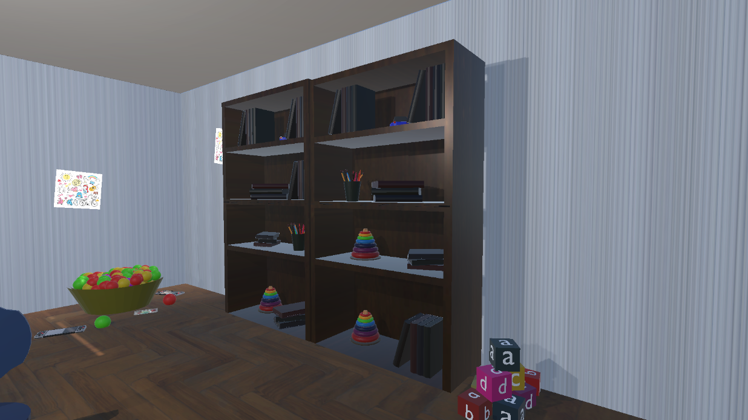

In Figure 1 that is shown above, 2 somewhat similar shelf sets are visible. Everything on the shelves, including the shelves themselves, has been designed by me using the basic shapes that Blender has to offer. The ballpit and stack of alphabet cubes have also been designed by me without any additional assets.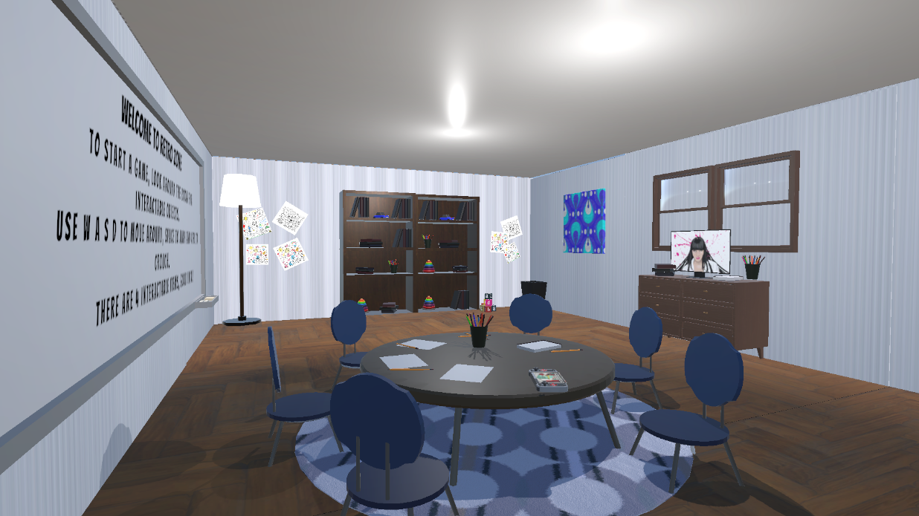

All of the chairs, table, pen cup, pens and papers have also been designed by me and it is important to mention that all of these items do have collision enabled so it is imposible to walk through them but due to the players ability to jump and crouch, climbing on the table is possible.

The dresser, trashcan, computer, game console and windows on the right-hand side do not belong to me and I do not take any credit for making them as they were simply imported from the Unity Asset store. This was also mentioned in the Credits screen in the Options menu. The same disclaimer applies to the whiteboard and lamp on the lefthand side and the carpet and floor.

Since I work alone, I take full credit for the creation of the models that I did not import from the Asset Store.

1. Work in Unity

The game started off relatively easy with a simple start menu that only took less than an hour to make. The part that became slightly more tricky is tying different scenes together due to my overall lack of knowledge of Unity and C# and how they work.

The second screen that I will label as „The Game“ was even more tricky due to me importing my models only to realize that none of the materials I have originally used in Blender have transferred over to Unity. So recreating the materials has taken a decent amount of time and patience.

Once that has been done, I had to find a way to use my items as clickables so that the player can be put into the actual playable mini games. This is where my flawed logic has put me into a massive loop of failure. My repeated attempts of making objects into buttons have left me wondering if my objects can even be used as buttons and many hours and cups of coffee later, I did it.

The game console that can be found on the table is used as a transition between the „The Game“ and the first mini game, Asteroids. The computer on the dresser is used as a transition between „The Game“ and the second mini game, Wordle.

Now, the original plan for the game was to feature games such as Tetris, the Dinosaur Runner that users can play on the Chrome browser when the internet is out, Pong, PacMan and FlappyBird but due to the limitations of my knowledge, those features will be left as future implementations that the game can wait for.

Once major reason why that is the case is due to my lack of understanding how the GameController script works and me being inable to have more than one in my whole project but I am sure that with time I will be able to overcome that obstacle.

When it comes to the movement in the game, the game supports W, A, S, D movement, mouse click interaction and shooting and mouse movement to look around and explore. Additionally, the game is supposed to be a first person game with the exception of the mini games and while the character is not physically visible, they do exist, this can be confirmed with the players ability to see the the characters shadow. Now, the „character“ is not really a character but rather a capsule that was converted into a person controller that will act and move like a person and since they do not have any other purpose for now other than allowing the player to explore, being capsule shaped is not that game changing.

The physics are pretty straightforward. The player follows the basic „Earth-like“ physics so they cannot fly, move unhumanly fast or walk through objects but the Asteroid game does make the „player“ pawn swerve and float around as if it was in a zero gravity space.

Wordle does not have any movement but it does register all keyboard strokes and chooses to ignore everything that is not an alphabetical letter. Wordle will also push out a warning if the player tries to use a word that is not listed in the Wordle dictionary.

The game instructions are very simple and straightforward but they are still provided on every screen. The player can walk around in the room using W, A, S, D and mouse click to interact. In Asteroids, the player can use W, A, S, D to fly around and mouseclick to shoot. And in Worlde, the player can use all of the keys on the keyboard to play the game and the mouse to navigate back into the „lobby“ or starting menu.

Due to me working alone, all of this was put together by me and a lot of youtube tutorials that have broadened my knowledge of Unity so much.

1. Conclusion

Now, even though the game is finished, I am sad that I could not put more into it as I have ended up liking the idea quite a lot. The whole transition from an educational kids game to a game that can be played by pretty much anyone has increased my motivation to invest myself into it by a lot. The idea of having an adult who can play my game to just blow some steam off after work or during their break just because the game is not hard nor does it punish the player for losing has left a pretty nice feeling in me. The original inspiration behind the games I chose is Solitire, my favourite passtime minigame. I like the idea behind being able to pick up a game whenever and playing it for however long I want to without having to become stressed or annoyed over losing is something I strived to achieve with this game. Additionally I feel that a lot of players will like not having to be fully attached to the game to the point where they have to sign in every day to collect a reward or keep a streak going mainly due to the fact that losing the streak or missing the reward would demotivate them and later maybe even cause them to stop playing the game because the lost streak was too large or the missed reward was too valuable.

Overall, I am a little sad that I have made the choice to work on this project alone because I saw so many directions that this game could have gone in and working alone has just caused a lot of potential to go unrealized. I am sure that I will revisit this project later on and expand it drastically along with my knowledge of Unity and overall game development but for now, I am satisfied with the work I have done.

Lastly I would like to dedicate this final paragraph to Feđa Cumbo for helping me as much as he could throughout the project and also you, Professor Belma, for being more than understanding and tolerant of me when I needed it the most. This semester has been a rollercoaster for all of us and I am so grateful that you were there for me even though we have crossed paths only a few months ago.

1. References

Asset Store Imports:

1. Apartment Kit by Brick Project Studio
2. Mini First Person Controller by Simon Pasi
3. School Assets by A.R.S|T

Resources are from the official New York Times web page and the player icon and asteroids are from Zigorous on Youtube.